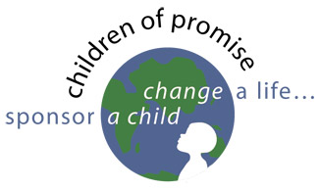
Today, we welcome Kirk Bookout from Children of Promise.
Kirk is the Development Director for the program.

North Main Street Church of God has a vision to make a difference in the world for Jesus! The sponsors from Butler help provide many wonderful core benefits for children. Children of Promise reports that 56 children are sponsored through the church and people in Butler in 13 different countries. 31 of the children are sponsored in Uganda. Each and every day these children's lives are amazingly better, and they have a hope for a brand new future as the sponsors make these four core benefits possible:

- Nourishing food to eat.
- Health care - large or small. (there is an emergency funds for major medical needs.)
- Education - in 29 out of the 30 countries we are in, a child must have a uniform and pay school fees. The vast majority of the children of COP could not go to school.
- Faith Development, as the children not only hear about a God who loves them, but they see it.

And there are unexpected consequences you will hear about today!

www.echildrenofpromise.org

Today, we welcome Kirk Bookout from Children of Promise.
Kirk is the Development Director for the program.

North Main Street Church of God has a vision to make a difference in the world for Jesus! The sponsors from Butler help provide many wonderful core benefits for children. Children of Promise reports that 56 children are sponsored through the church and people in Butler in 13 different countries. 31 of the children are sponsored in Uganda. Each and every day these children's lives are amazingly better, and they have a hope for a brand new future as the sponsors make these four core benefits possible:

- Nourishing food to eat.
- Health care - large or small. (there is an emergency funds for major medical needs.)
- Education - in 29 out of the 30 countries we are in, a child must have a uniform and pay school fees. The vast majority of the children of COP could not go to school.
- Faith Development, as the children not only hear about a God who loves them, but they see it.

And there are unexpected consequences you will hear about today!

www.echildrenofpromise.org

